



**SM6P07NI Digital Media Project**

**20% Research and Proposal**

**2018-19 Autumn**

**Student Name:** Rahul Balami

**London Met ID:** 22067315

**College ID:** np01mm4a220025

**External Supervisor: Pooja Shrestha**

**Internal Supervisor: Rakshak Bhusan Bajracharya**

**Assignment Due Date: 8th Jan 2025**.

**Assignment Submission Date:8th Jan 2025**

**Word Count: 3232**

*I confirm that I understand my coursework needs to be submitted online via My Second Teacher under the relevant module page before the deadline in order for my assignment to be accepted and marked. I am fully aware that late submissions will be treated as non-submission and a marks of zero will be awarded.*

Abstract

This project involves creating a story-driven pixel art platformer game where the main character is a cat on a journey to find its family. The game combines captivating visuals, engaging gameplay mechanics, and an emotionally resonant narrative. Players will guide the cat through various levels, overcoming obstacles and solving challenges to progress in its heartfelt quest.

The documentation includes an overview of the project, detailing its conceptualization, design, and development phases. It also covers the evaluation methods, testing processes, and reflections on the creative and technical journey involved in bringing this unique game to life.

Contents

Section A: Research 1

1. Introduction 1

2. Literature Review 2

2.1. Animation Principles 2

2.2. Game Mechanics and Player Engagement 2

2.3. Game Music 3

Setting the Mood and Atmosphere 3

2.4. Types of Game Music 4

Background Music 4

Dynamic Music 4

Thematic Music 4

3. Product Review 5

Stray: 5

Overview: 5

Strengths: 5

Criticism 6

Celeste: 6

Criticism: 7

Super Mario Bros: 8

Overview: 8

4. Summary and Conclusions 9

5. Section B: Project Proposal 9

Project Title 10

Research Question 11

Treatment 12

Resources 13

Production Platform and Software: 13

Resource Assessment: 13

Software Requirements: 14

Production Team Skills: 14

Indicative Time Frame: 15

Contribution of Others 16

Evaluation & Testing 16

References 19

Bibliography 20

Appendix 21

# Section A: Research

# Introduction

For my final year project, I will develop a 2D pixel art platformer game that. Inspired by the acclaimed games Stray and Celeste, this project aims to create an immersive experience by blending exploration, emotional storytelling, and challenging platforming elements.

The main character of this game is going to be a cat that is going to traverse through a variety of different environment facing various challenges.. The narrative will explore themes of resilience, connection, and self-discovery, providing players with a meaningful and memorable journey. The pixel art style will enhance the game’s nostalgic charm while offering modern gameplay features to appeal to a broad audience.

This project will demonstrate my ability to integrate programming, artistic design, and narrative development into a cohesive gaming experience. It also provides an opportunity to apply technical skills acquired during my studies, including game design principles, coding, and pixel art creation. By delivering a polished and engaging game, I aim to showcase the potential of pixel art platformers to tell impactful stories while providing an enjoyable gaming experience.

# Literature Review

## Animation Principles

The 12 Principles of Animation which was defined by two Disney animators who are Frank Thomas and Ollie Johnston had become a backbone of the creation of dynamic and engaging visual effects within games. The principles of squash and stretch, anticipation and timing, all served to help sell the motion and character. The movement and interaction that were designed by the protagonist, created a natural and responsive sensations with the principles that are mentioned above. For example, to signal the actions such as jump or attack using anticipation, enhanced the feedbacks and immersion from the player.

## Game Mechanics and Player Engagement

The gameplay in the cat-themed 2D pixel art platform is designed to provides experience for players to face both challenge and enjoyment, making sure that the players are engaged throughout the gameplay. The game exploits core platform elements such as jumping, wall climbing and lastly dash to transverse challenging levels. The stealth mechanics lets players to sneak past the enemies. Additionally, the combat features ensure the opportunity for strategic encounters.

The game offers various challenges to enhance the player engagement such as collectible items, coins or scrolls. The completion of these challenges offers the player a reward exploration. The progression system allows players to unlock new abilities or upgrade of their ninja the game has to offer leading to a sense of accomplishment of the game play which motivates the players to continue player to move forward.

The levels of the game are designed in such a way that the high the level the higher the difficulty, introducing new obstacle and new enemies to face. The visual cues and animation guide the player whereas the intuitive controls and gives responsive feedbacks which ensures a smooth gameplay.

The main goal of the game aims to captivate the players. The immersive pixel art, soundtracks, and narratives supports the engagement in the game. As a result, combining the challenges, gamers are stimulated to replay the game after beating it once due the rewarding progression.

## Game Music

Game music is defined as the audio and soundtracks that are created specifically for video games to enhance the gaming experience for the players. Game music is an integral part of the game as it influences mood and atmosphere. It plays a huge role of supporting the dynamics of the gameplay. Game music is more on the interactive side that adapts the actions which creates a seamless experience of the gameplay.

### Setting the Mood and Atmosphere

#### The Game music is the tone of the game. The main goal of the cat-themed 2D pixel art platformer game in terms of game music is the implementation of both fun and engaging music. Taking example of game music of Mario game, it gives off a catchy melody that matches the fast-paced gameplay which keeps the players engaged in the game. Similarly, the mood and atmosphere for the cat-themed 2D pixel art platformer will give off the similar mood as the Mario game.

#### Enhancing Immersion

#### The music of the game draws the player in the gameplay, making music one of the most crucial implementation of a gameplay experience. It connects the players emotionally with the environment, story of the game as well as the character. Due to the importance of choice of music, the right soundtrack can make the game more alive and compelling.

#### Guiding the Player

The guidance of player in the game can be done through the game music. It can provide an audio cue to address a specific event. For example, a sudden change in tone of game music alerts the player from a nearby incoming enemy.

#### Reinforcing Rewards and Achievements

The achievement of rewards and achievements plays a huge role on engagement of the players as it encourages players to continue the gameplay to achieve more. For example, the implementation of Victory themes and power-up sounds provide positive reinforcement which encourages players to progress through the game.

## Types of Game Music

### Background Music

The background music of a game plays continuously to set the mood and tone that maintains the consistency. For example, a game of exploring with a ambient music can keep the players focused while creating a sense of mystery or danger.

### Dynamic Music

The dynamic music adapts to the game play. The music changes in real-time during the change of game state or player’s action. For example, when a player enters a safe or danger zone, the music intensifies during the combat.

### Thematic Music

The thematic music designs unique track for key moments. The music connects deeply with the player to the story of the game and characters.

# Product Review

The product reviews of the inspirations for the game are listed below.

## Stray:

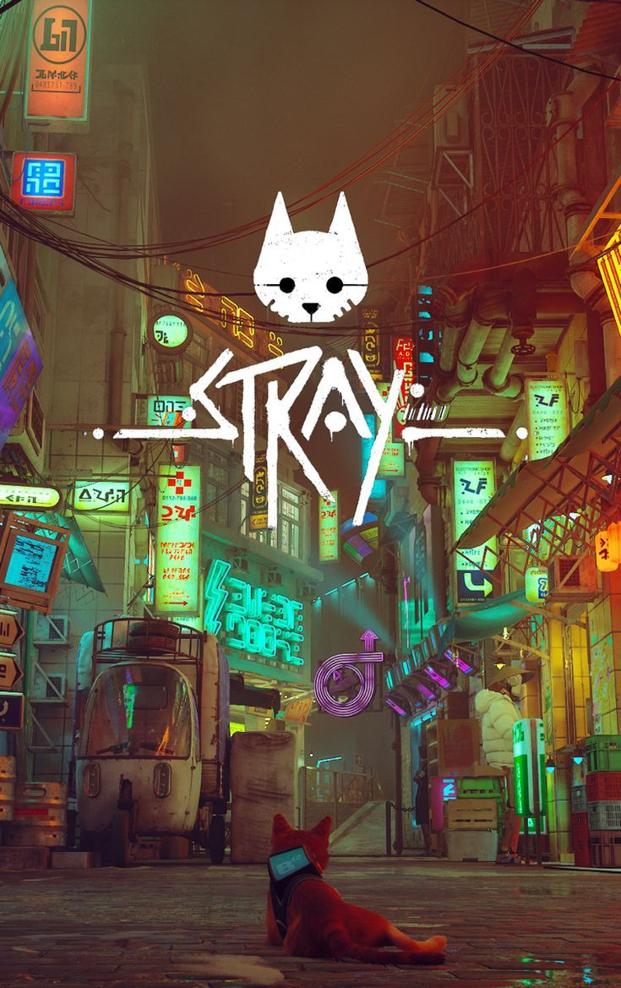

Figure

### Overview:

Stray is a game developed by Blue twelve Studio. It is a game that follows the story of a stray cat, hence the name. Its Setting is in a cyber punk city where the cat has to solve puzzles, interact with the robots in the city and find his way back home. It is a 3d game and its premise, Movement and gameplay are truly outstanding.

### Strengths:

This game is widely appreciated due to its unique premise and story telling style. It is played through the eyes of a cat and how the cat interacts with its unique environment. It has a unique and wellcrafted story, the setting is in neon lit city scape. It is a cyberpunk city which is taken over by robots. It is a postapocalyptic world where the cat is finding out new stuff. The unique playstyle, engaging gameplay, and superb storyline helps the player truly immerse themselves into the game.

### **Criticism**

Some criticisms of the game are repetitive mechanics and limited interactions.

## Celeste:

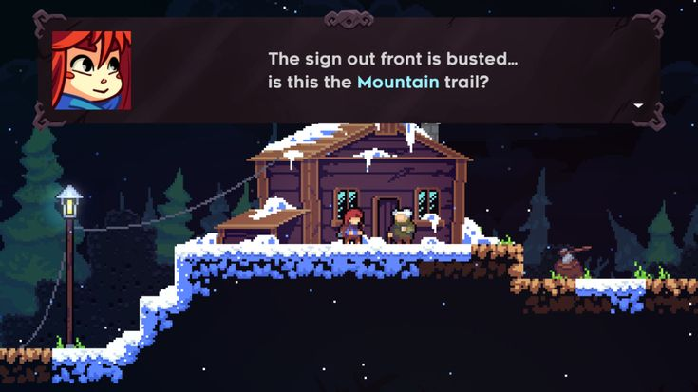

Figure

#### Overview

Celeste is an indie platformer game. It is developed by Maddy Makes Games. It is the story of a character named Madeline, who decides to climb the mountain Celeste, to challenge her anxiety. It reflects mental struggles in real life with the game. Its setting is in a beautifully crafted 2D pixel art platformer world.

#### Strengths:

Celeste is a widely loved game all over the world due to its heart felt story, engaging playstyle and the beautiful art work. It follows a character going through mental struggles, and is a great portrayal of mental health issues. This helps players with such issues themselves connect greatly to the story of the game. The mechanic of this game are truly astounding. With only a few moves, there are so many possibilities. The game devs manage to make the game have very complex and unique movements while maintaining their simplistic approach. The emotional narrative, beautiful artwork, Immersive, smooth and great movement makes this game a truly remarkable example for indie game developers on how even a simple game type as a 2d platformer can be made into such a intricate and beautiful piece of media.

### Criticism:

Some criticisms include the steep difficulty curve that might not appeal to all players, and the story can be interpreted in a way that may not fully engage those unfamiliar with the themes of mental health.

## Super Mario Bros:

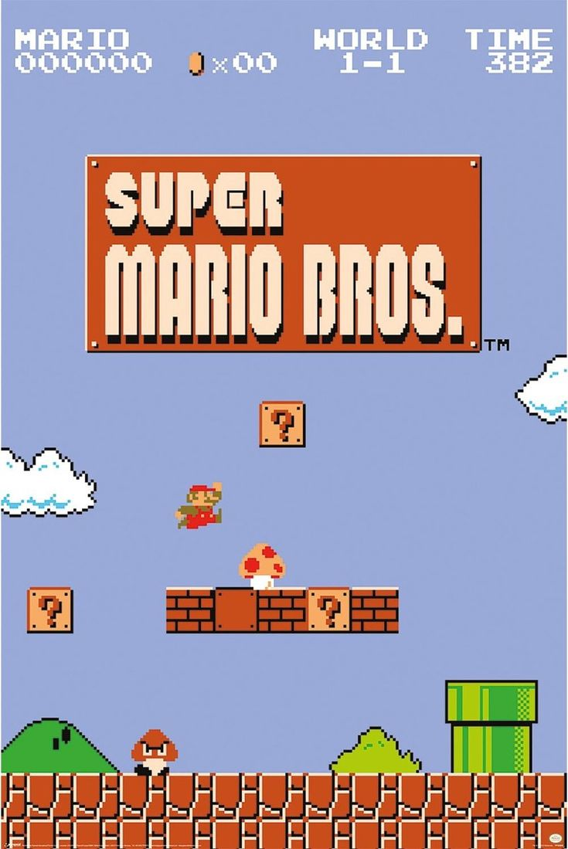

Figure

### Overview:

The game that revolutionized the platforming genre which was developed by Nintendo known as Super Mario Bros. The players named Mario and Luigi go on a mission to rescue Princess Peach and the mushroom kingdom. The feature of the game has innovative design, catchy music and sound effects that has become a stable of the entire gaming history.

#### Strengths:

Super Mario Bro is simple, well-done gameplay with tight controls and challenging, setting the example for platformers. Its pixel art compared to modern games is simplistic as it contains iconic character designs and bright backgrounds. The famous music that was created by Koji Kondo, enhanced the flow and feel of the game. The well-known sounds such as the coin chime and power-up noises, make players feel more involved. The clear story of saving Princess Peach and the music/sounds makes it emotional leading to the connection of player and the game. Super Mario Bros changed platform games by introducing new ways to play and using music and sounds as important parts of the story.

#### Criticism:

Many people enjoy Super Mario Bros, but some players might find the levels challenging as levels go higher. Additionally, the loop of music can also become repetitive if one plays for an extended period.

# Summary and Conclusions

The rich history of the platformer genre with iconic games such as Super Mario Bros and Celeste serves an engaging gameplay as well as emotional connection. The games mentioned above shows the importance of how visual design, narratives, tight controls make a huge impact on the gameplay and to create immersive experience of the players. Super Mario bros transcend in audio design while celeste places more on narrative as well as the mental health aspect.

The project I developed revolves around a cat as the main character for the game. I have taken concepts from the two games (Super Mario bros, celeste) but also added features to make it different. The story revolves around a cat that is looking for its lost siblings and has a good story to go along with it. It also mixes exploration, puzzles and challenges to create a truly enriching experience. New mechanics are introduced in the body of the work such as the story of the bond between the siblings and the abilities of a cat.

This venture is an extension of the two classics mentioned above. It fuses Celeste’s depth of feeling and Super Mario Bros’ ageless ease. In its exploration of the topic of siblings/family, it presents a different angle in the platforming genre. By using narrative approach the game became a qualitative new product for the genre.

# Section B: Project Proposal

## Project Title

Project Title: Purrkour

Brief Description:

Purrkour is a 2D pixel art platformer game featuring a nimble cat on a heartfelt quest to reunite with its lost family. It combines nimble movement mechanics, a compelling narrative and provides a unique experience to the player. I will blend retro and modern styles to create a unique blend of a different product.

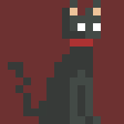

Figure

## Research Question

How can a pixel art platformer game utilize its visual and narrative design to create an engaging and emotionally compelling player experience while maintaining its playful and fun playstyle?

## Treatment

In Purrkour, player is a curious and agile cat. It explores its unique new enviroments as it looks for its lost family. It is filled with different things, hidden aspects, fun challenges and a heart felt story about this cat and its journey to find its family. It also has various other characters with whom the cat interacts with to give the world of this game immersion.

The target audience of this project is going to be primarily PC gamers that lean more into indie gaming. The genre us going to me adventure and exploration.

## Resources

### Production Platform and Software:

Aseprite: Used for creating and animating pixel art sprites.

GDevelop: A no-code game engine for writing game logic using if - then mechanics.

Reason: Used for composing and producing the game’s music and sound effects.

Level of Interactivity:

The game will be highly interactive, with responsive controls, dynamic environmental elements, and engaging puzzles to enhance player immersion.

Distribution Platform:

The game is planned for distribution on PC platforms, with potential scalability for mobile devices

### Resource Assessment:

#### Hardware Requirements:

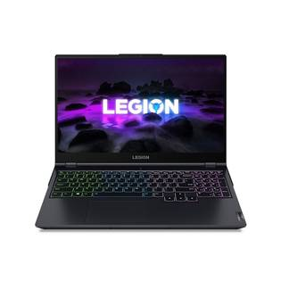

Figure

A computer with moderate specifications capable of running Aseprite, GDevelop, and Reason efficiently.

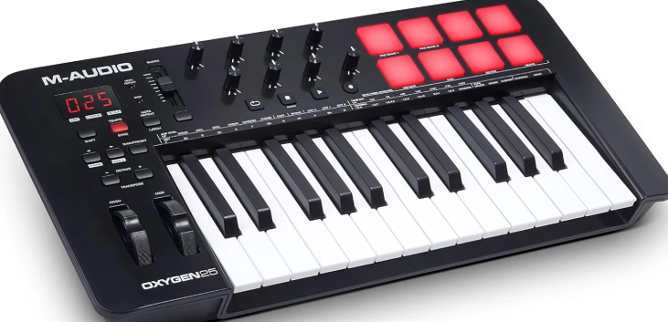

Figure

Basic production equiptment like midi

### Software Requirements:

1. Licensed versions of Aseprite, GDevelop, and Reason.

2. Optional free software tools for additional tasks, such as Audacity for audio editing or tiled for level design.

### Production Team Skills:

Pixel Art Design: Ability to properly design in aseprite

Game Development: Ability to code in Gdevelop

Music Production: Knowledge in music and recording software(DAW)

Project Management: Ability to coordinate and manage the project timeline effectively.

.

### Indicative Time Frame:

Research and Pre-production (2–3 weeks):

Conceptualizing the game design and narrative.

Conducting market research and audience analysis.

Creating initial sketches, storyboards, and asset lists.

Production (8–10 weeks):

Creating sprites, animations, and game assets in Aseprite.

Developing game logic, mechanics, and levels in GDevelop.

Composing and integrating music and sound effects using Reason.

Testing and Evaluation (3 weeks):

Conducting user testing to identify and fix bugs.

Refining gameplay mechanics and difficulty balance based on feedback.

Evaluating overall user experience and making necessary adjustments.

Finalization (2 weeks):

Total estimated time: 14–16 weeks.

## Contribution of Others

Supervisors

Providing Guidance:

My supervisors are going to provide valuable insight on how to achieve the project. They provide with achievable goals that are set every week which helps in completion of the project.

Problem-Solving Support:

In case of challenges in coding design, or any other matter, the supervisors support us in every way possible by fixing issues, or providing required resources to do so.

Quality Checks:

They review the prototype of the product and give their feedback accordingly to the needs and shortcomings of the project.

Friends

Providing Feedback:

My friends will provide with different feedbacks and insights that cannot be thought up by a single person.

Conducting Test Runs:

They will help by playing with the prototype and giving their suggestions and insights on the game as the developer will have a more biased opinion.

Offering Suggestions:

Based on their experience with the game, they’ll suggest enhancements to improve player engagement, level design, or visual appeal.

## Evaluation & Testing

To ensure the quality and success of my story-based platformer game, I will evaluate the project using several methods, detailed below:

1. Playtesting

Playtesting will be a crutial part of the production to check for immersion of the game, quality and to check if there are any bugs.

2. Feedback Collection

Feedback will be collected from various different people in order to form a coheassive idea of the general perception of the gam

3. Bug and Technical Testing

Various tests will be done to check If the game has bugs or not.

4. Supervisor Review

The supervisors will review the project on each and every step of the way to ensure the proper completion of the coursework

5. Reflection and Documentation

Throughout the development process, The process, research and everything relation to the production, planning and completion of the project will be documented.

# References

Celeste Game (n.d.) Celeste. Available at: https://www.celestegame.com (Accessed: 6 January 2025).

Nintendo (n.d.) Super Mario Bros. Available at: https://www.nintendo.com/games/detail/super-mario-bros-switch (Accessed: 6 January 2025).

GDevelop (n.d.) GDevelop Game Engine. Available at: https://gdevelop.io (Accessed: 6 January 2025).

Aseprite (n.d.) Aseprite - Animated sprite editor and pixel art tool. Available at: https://www.aseprite.org (Accessed: 6 January 2025).

Reason Studios (n.d.) Reason Software. Available at: https://www.reasonstudios.com (Accessed: 6 January 2025).

ResearchGate (2022) Research on the Application of Pixel Art in Game Character Design. Available at: https://www.researchgate.net/publication/362831872_Research_on_the_Application_of_Pixel_Art_in_Game_Character_Design (Accessed: 6 January 2025).

Repository Library, Northeastern University (n.d.) Integrating Visual Effects into 2D Platformer Games to Enhance Play. Available at: https://repository.library.northeastern.edu/files/neu:bz60mb56x/fulltext.pdf (Accessed: 6 January 2025).

<https://www.pinterest.com/pin/774124929665727/>

<https://www.pinterest.com/pin/46021227437464673/>

<https://www.pinterest.com/pin/782078291573131053/>

<https://www.bajaao.com/blogs/blog/how-to-choose-midi-keyboards-buying-guide>

<https://itechstore.com.np/archived/product/Lenovo-legion-5-amd-ryzen-7-5800h-rtx-3060-laptop-in-Nepal/>

# Bibliography

<https://www.celestegame.com>

<https://www.nintendo.com/games/detail/super-mario-bros-switch>

<https://gdevelop.io>

<https://www.aseprite.org>

<https://www.reasonstudios.com>

<https://www.researchgate.net/publication/362831872_Research_on_the_Application_of_Pixel_Art_in_Game_Character_Design>

<https://repository.library.northeastern.edu/files/neu:bz60mb56x/fulltext.pdf>

<https://www.sandromaglione.com/articles/pixel-art-platformer-level-design-full-guide>

https://www.polygon.com/gaming/460227/indie-immersive-simulation-games-genre- trend

<https://www.youtube.com/watch?v=B8q1BCHoZcE>

# Appendix

## Client information

The name of the client is Sovit Poudel. He is a member of the company Truenary Solutions. It is an IT company that resides in Nepal.

## Permission Letter

